**Great Venue • Great Content • Great Value  
  
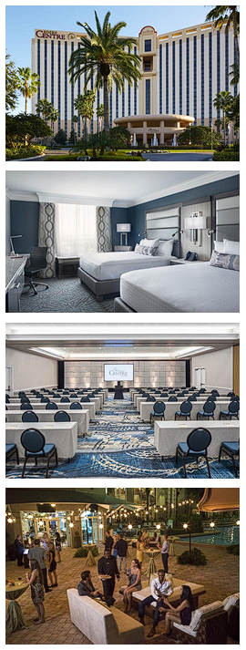Great Venue**  
The 2023 CCM Summit is being held at the Rosen Centre Hotel in Orlando, Florida.

Our group rate is $198 USD per night, which includes complimentary Wi-Fi, and is just an elevator ride from our meeting spaces and vendor forum. This prestigious property boasts numerous awards throughout the years providing an exceptional customer experience for both business travelers and families.  
  
**Great Content**  
The summit program features two primary tracks: Business and Technical. Each track is a unique blend of sessions addressing a variety of topics.  
  
**Great Value**  
Starting at $899 USD for members, the 2023 CCM Summit is an amazing value! There are dozens of educational sessions to expand your knowledge, daily networking events to expand your network, and access to leading-edge technologies in the vendor forum.

|  |  |
| --- | --- |
| **Who Should Attend?**  If you are reading this, **YOU**!  Anyone involved in the design, creation,  production, or distribution of  customer communications. | **First Timer?**  Never been to an annual conference before?  You may qualify for a FREE Summit Registration!  Our First Timer Recognition Program is now open so go to the link below for more information! |

For more information about 2023 Xplor CCM Summit, the First Timer Recognition Program, and speaking or exhibiting opportunities, please visit [www.xplor.org/2023CCMSummit](http://www.xplor.org/2023CCMSummit)